SHEFFIELD CHILDREN’S HOSPITAL PAEDIATRIC ORTHOPAEDICS AND TRAUMA SKILLS COURSE
10th-12th June 2020
VENUE: SHEFFIELD CHILDREN’S HOSPITAL
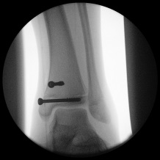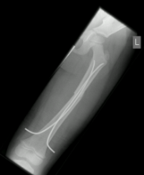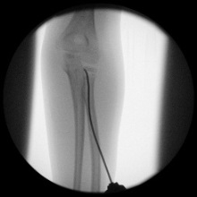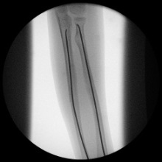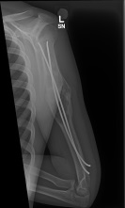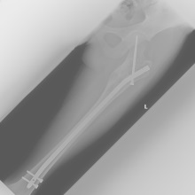
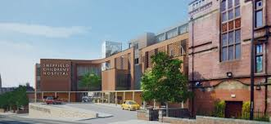
A 3 day course designed to cover paediatric practical skills for revalidating Consultants and Senior Trainees.
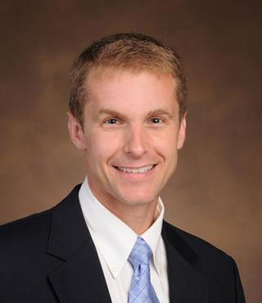
National and •International Faculty
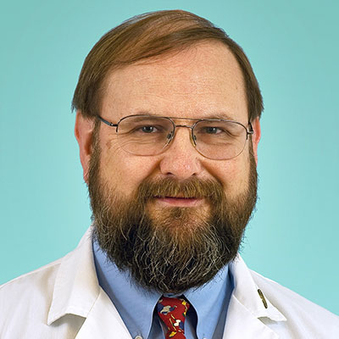
Professor Eric Gordon and Assoc. Professor Jonathan Schoenecker (so far confirmed)
•Trauma and elective topics with interactive lectures
•Breakout sessions with hands-on technique training, sawbone workshops and operative simulation
16 CME points given for previous courses
Further Information from: www.spotscourse.com
Email: kayleigh.burt@nhs.net
Course Fee: £350.00

